# File permissions in Linux

## Project description

As a security professional my organization has tasked me with examining and managing current permissions to keep the system secure. I would need to modify the permissions to authorize the appropriate users and remove any unauthorized access.

## Check file and directory details

I started by printing my working directory and then from there navigating into the /projects directory. I then used the “ls” command with the “-la” option to show all the permissions and details including those for hidden files.

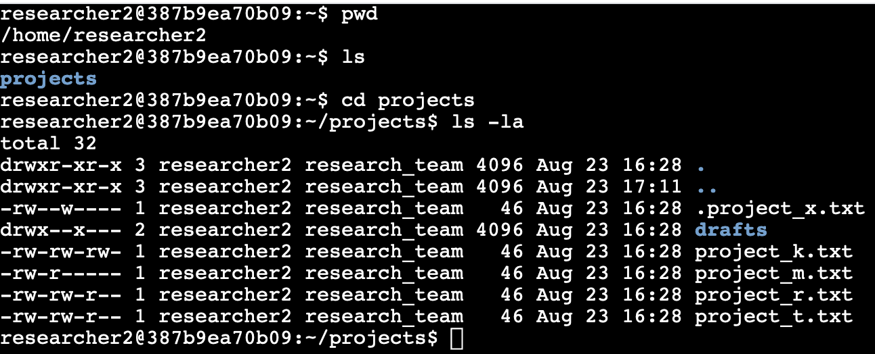

## Describe the permissions string

Using the “project_k.txt” file as an example. The 10 digit string at the beginning of the line describes the permissions for this file. The first digit tells us this is a file as indicated by the “-”, a “d” would indicate a directory. The next three characters describe the “users” access. “rw-” indicates the user has read, write, but not execute permissions which would be shown by a “x” instead of the hyphen as the third character. The following three characters show the “group” , which is “research-team”, and their permissions. They read the same as “rw-” again indicating the group has read and write permission but not execute. Finally the last three characters are the “others” permissions which is everyone else outside of the user and group. On this file they also have read and write permissions but not execute.

## Change file permissions

The organization does not allow other to have write permissions on any files, however other currently does have this permission on the file “project_k.txt”. To change the permissions I used the “chmod” Linux command along with “o-w” to remove write permissions from other.







## Change file permissions on a hidden file

The team has archived the now hidden file “.project_x.txt” and no one should have write permissions on this file, however user and group should be able to read it. Using the “chmod” command I adjusted the permissions to add read permissions to group while removing write permissions from user and group.

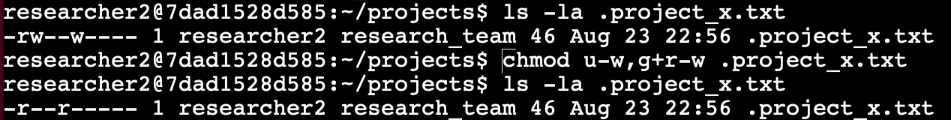

## Change directory permissions

The drafts directory should only be accessible to the user researcher2. Initially the group also had execute permissions in drafts as well. Using “chmod” I was able to remove the group execute permissions.

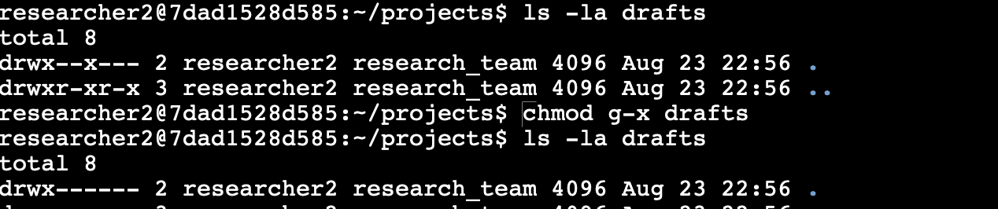

## Summary

During the project I was able to use Linux commands to navigate the file system and check permissions on files and directories. Understanding the 10 digit permissions string I was able to use the command “chmod” to appropriately alter the permissions for proper authorization of the user, group, and other.